Fitness And GYM

Developer Guide

|  |  |  |
| --- | --- | --- |
| **Supervisor:** | Sir Owais Ahmed Khan |  |
| **Batch:** |  |  |
| **Group:** | C |  |
| **Serial no.** | **Enrollment number** | **Student Name** |
| 1. |  |  |
| 2. |  |  |
| 3’. |  |  |



Home (index.html)

Figure 1: Home Page For Our (GYM) Fitness Website:

Our Slogan has given to the peoples toward our website. “The Fitness”.

* OUR HOME PAGE WELCOMES OUR CUSTUMERS WITH BEAUTIFUL QOUTE.

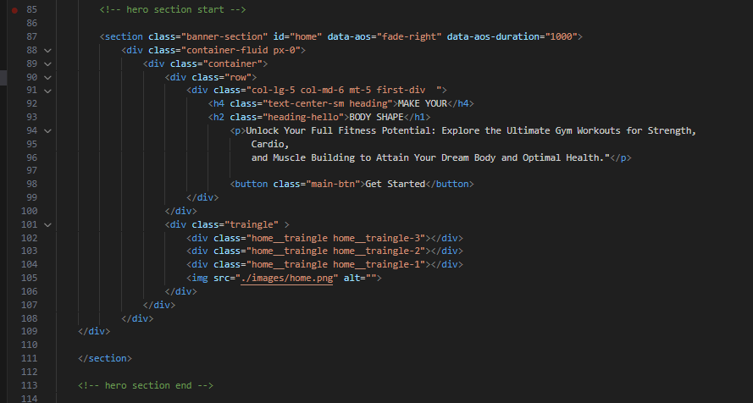Code Of Home Page:

Membership (Index.html)

PAGE OF MEMBER SHIP

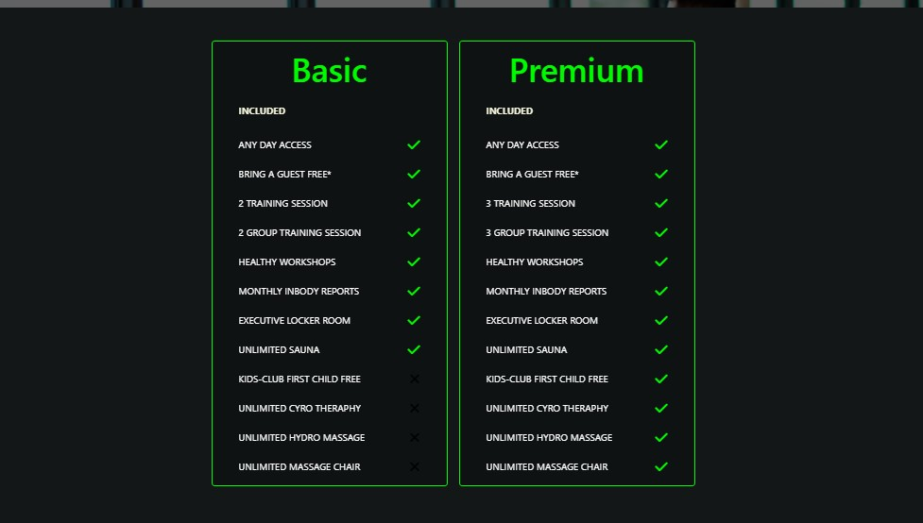Basic and premium

CODE OF MEMBER SHIP

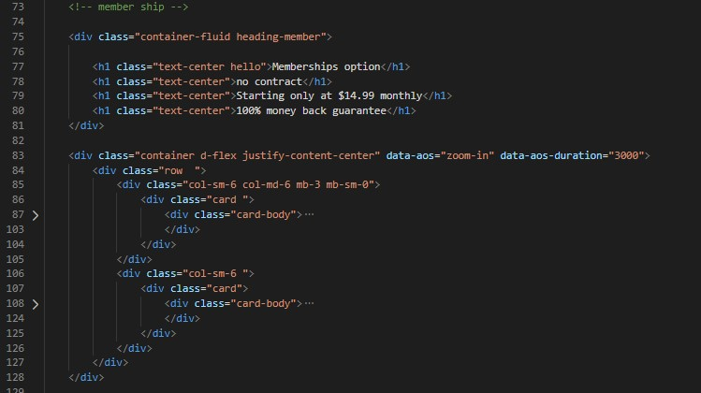Basic and premium

FOOTER (Index.html):

DESIGN OF FOOTER

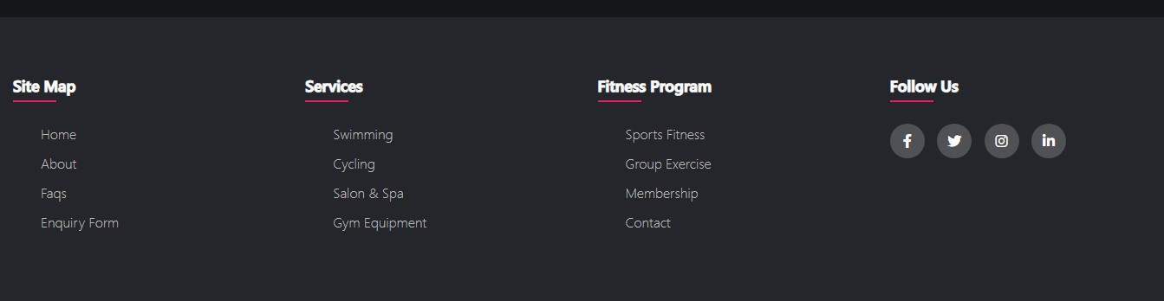CODE OF FOOTER

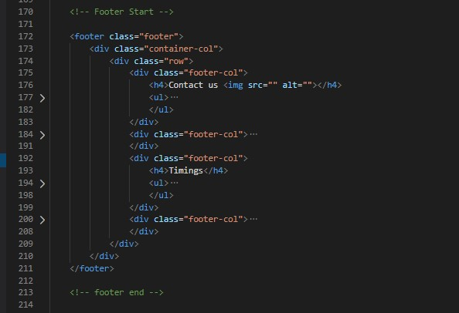

NAVBAR (Index.html):

DESIGN OF NAVBAR

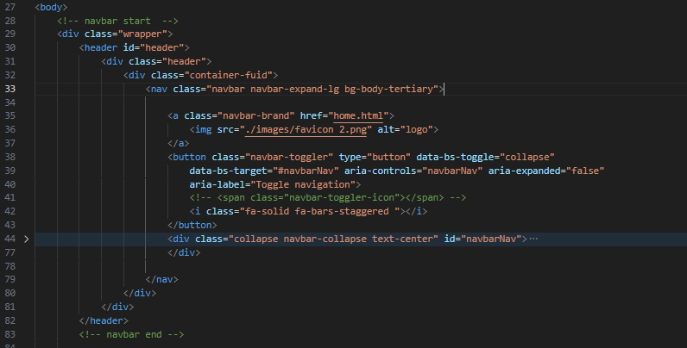CODE OF FOOTER

ABOUT US (Index.html):

DESIGN OF ABOUT US

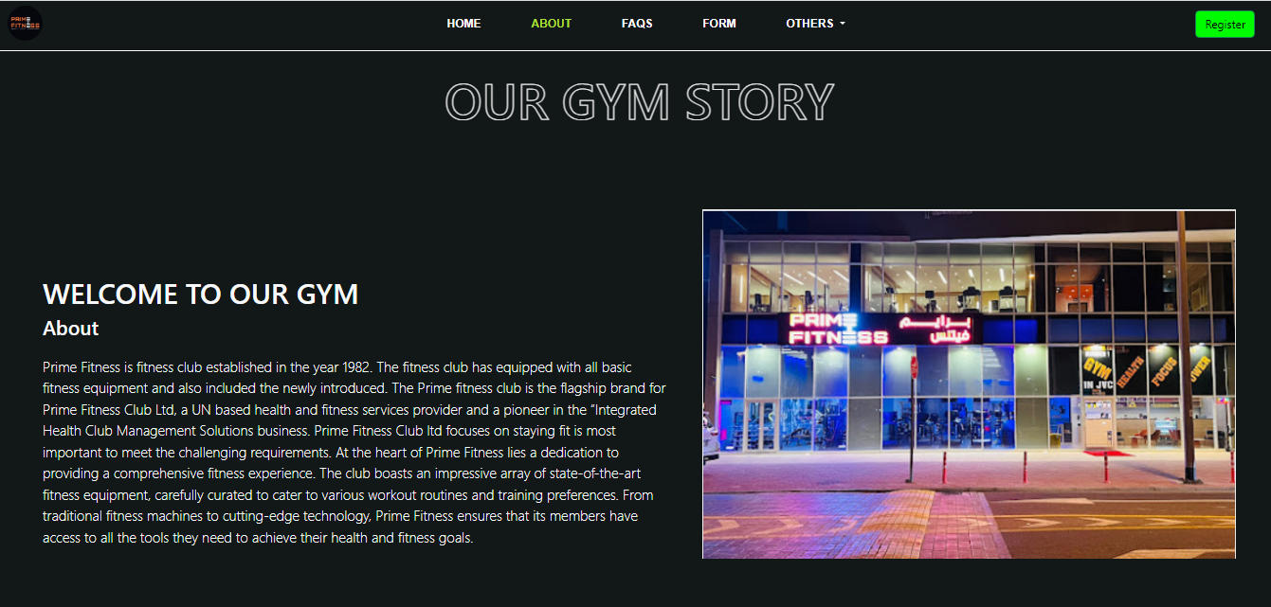

* We have given user an overview of who we are and what our journey is and what we have achieved.

(It’s contain 3 section)

CODE OF ABOUT US

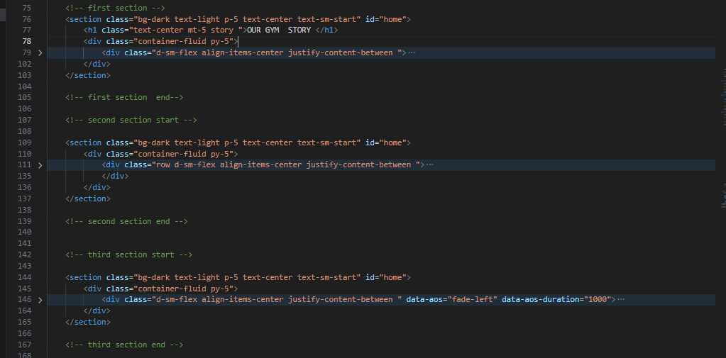

FAQS (Index.html):

CODE OF FAQ

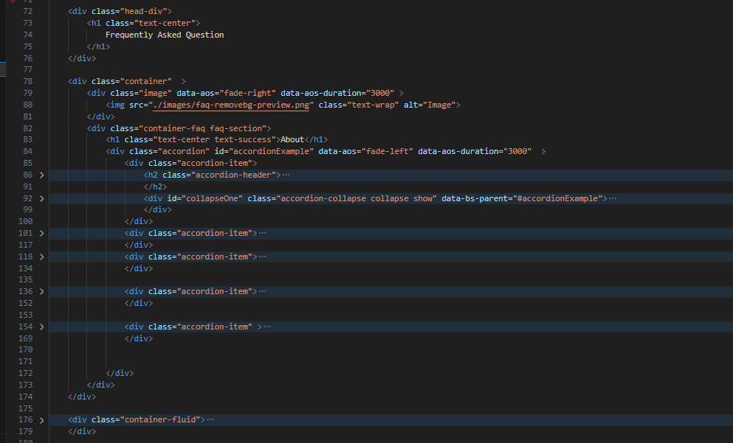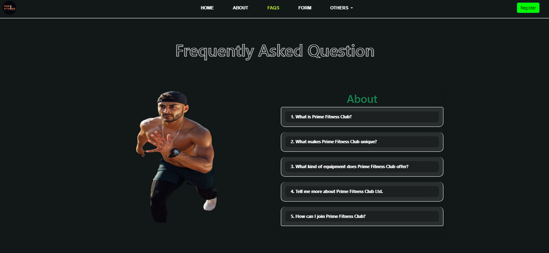 DESIGN OF FAQS

FORM (Index.html):

DESIGN OF FORM

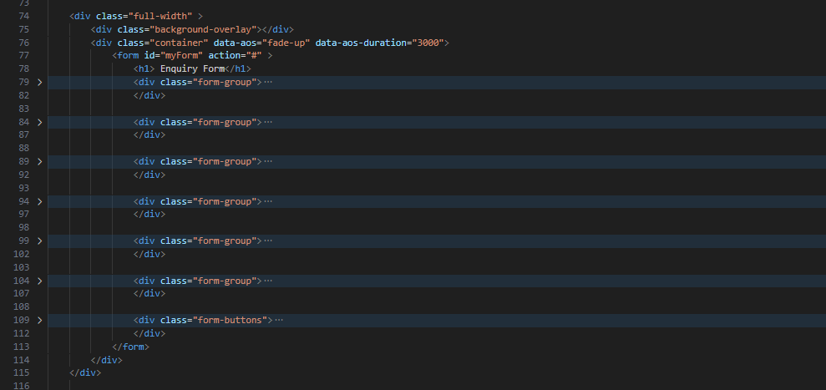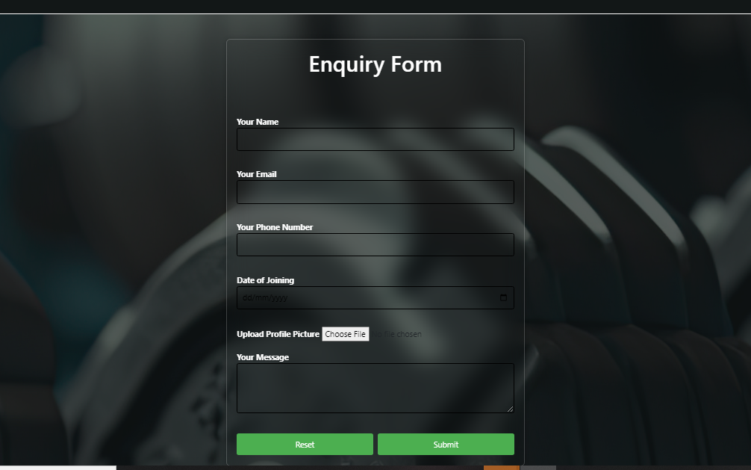CODE OF FORM

CYCLING (Index.html):

DESIGN OF

CYCLING PAGE 

* We have given user an overview of who we are and what our journey is and what we have achieved.

(It’s contain 3 section)

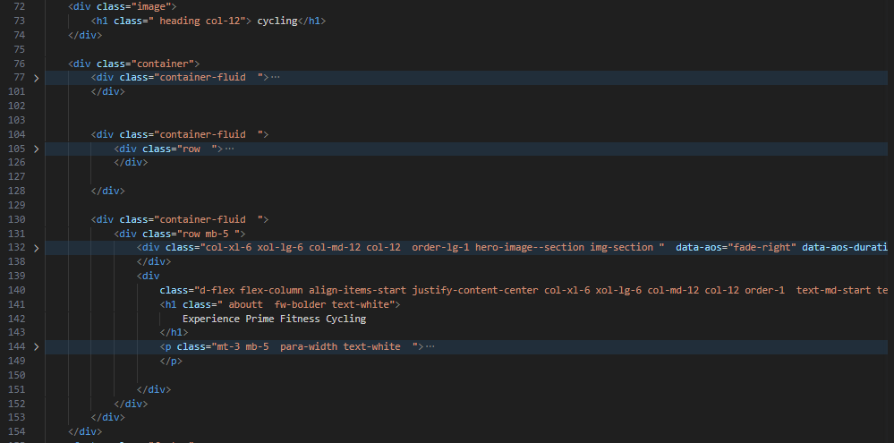CODE OF CYCLING PAGE

SWIMMING (Index.html):

DESIGN OF SWIMMING PAGE

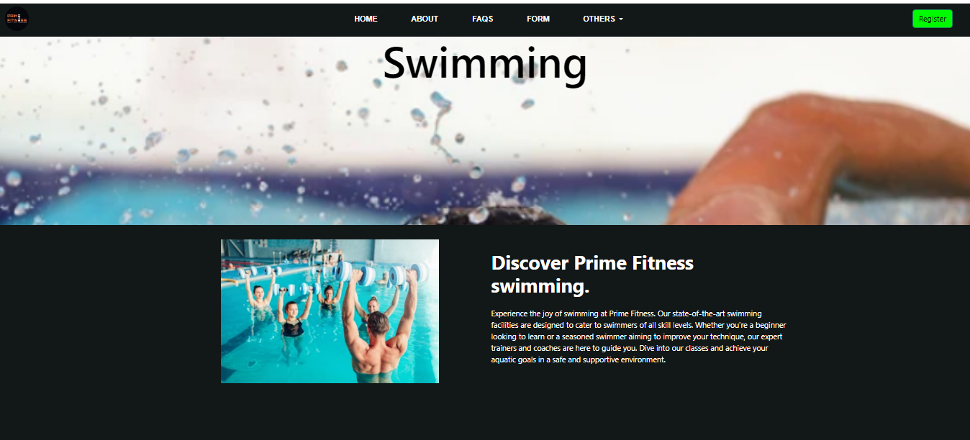

* We have given user an overview of who we are and what our journey is and what we have achieved.

(It’s contain 3 section)

CODE OF SWIMMING PAGE

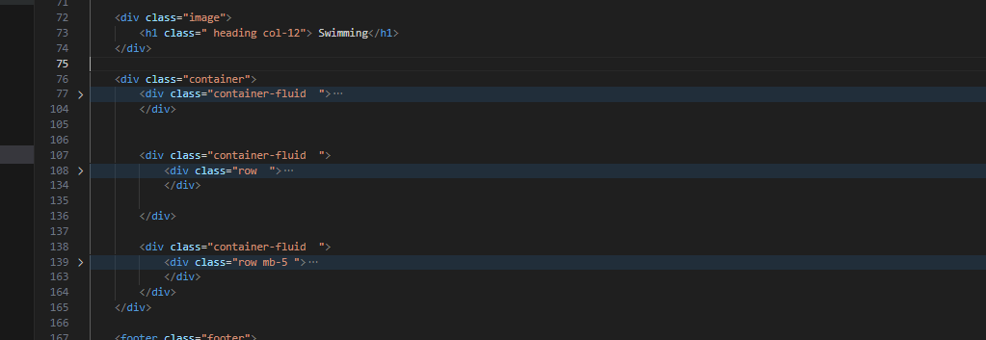

SPORT & FITNESS (Index.html):

DESIGN OF SPORT & FITNESS PAGE

* We have given user an overview of who we are and what our journey is and what we have achieved.

(It’s contain 3 section)

CODE OF SPORT & FITNESS PAGE

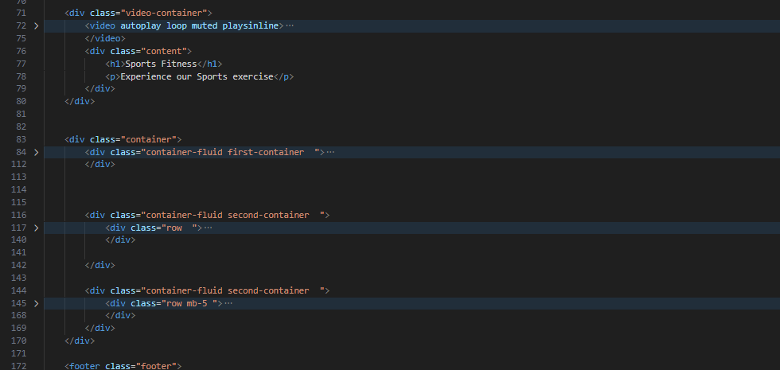

GROUP EXERCISE (Index.html):

DESIGN OF GRUOP EXCERCISE PAGE

* We have given user an overview of who we are and what our journey is and what we have achieved.

(It’s contain 3 section)

CODE OF GRUOP EXCERCISE PAGE

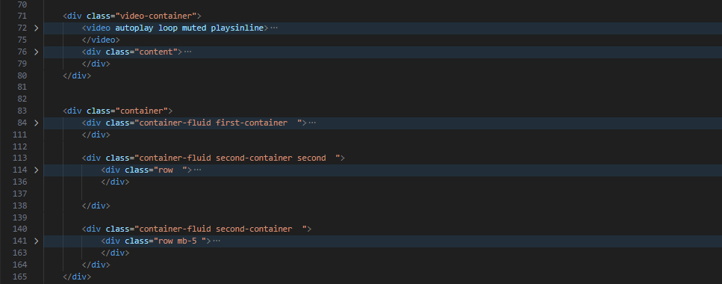

SALON & SPA (Index.html):

DESIGN OF SALON & SPA PAGE

* We have given user an overview of who we are and what our journey is and what we have achieved.

(It’s contain 3 section)

CODE OF SALON & SPA PAGE

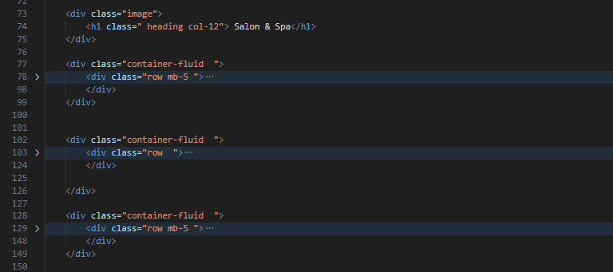

GALLARY (Index.html):

DESIGN OF GALLERY PAGE



(It’s contain 16 Pictures )

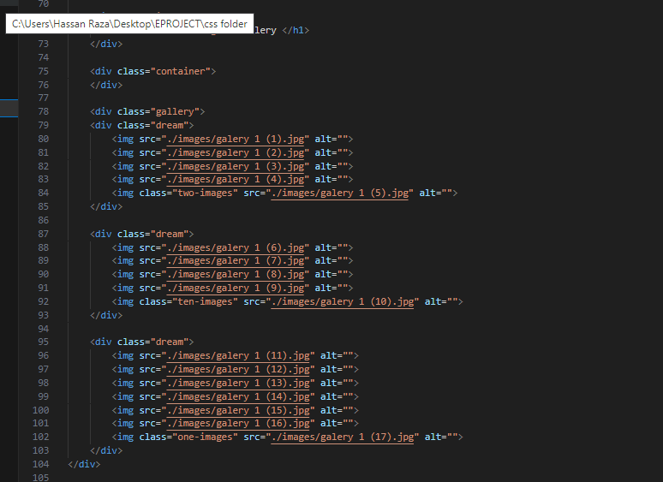CODE OF GALLERY PAGE

GYM EQUIPMENT (Index.html):

DESIGN OF GYM EQUIPMENT PAGE

(It’s contain 20 Products)

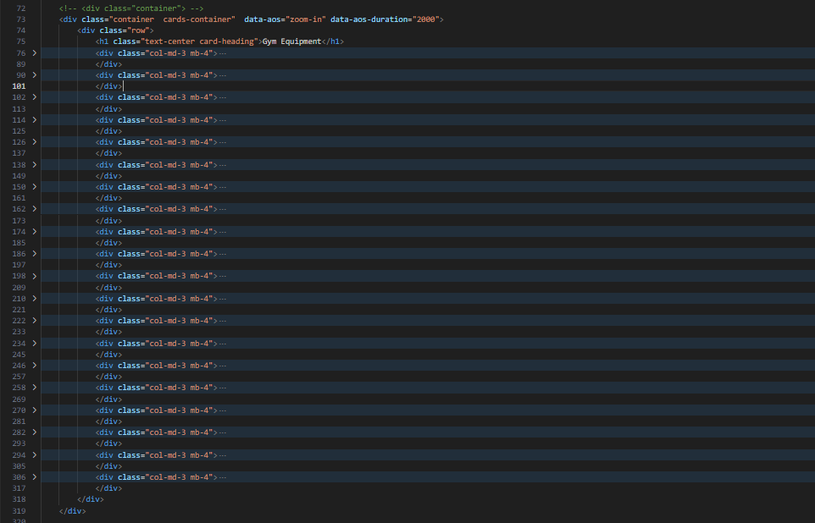CODE OF GRUOP EXCERCISE PAGE

CONTACT US(Index.html):

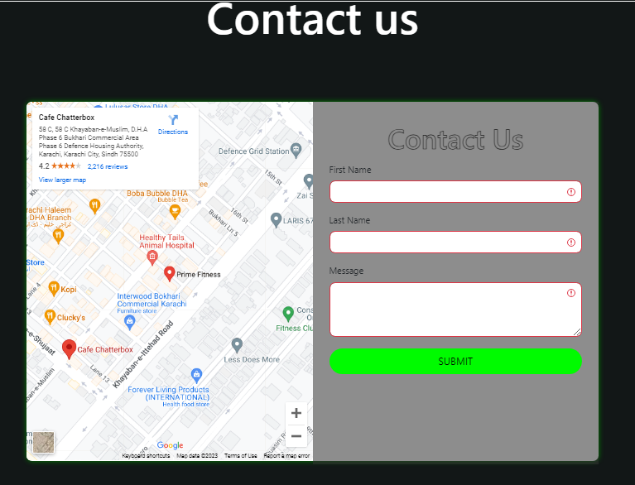 DESIGN OF CONTACT US PAGE

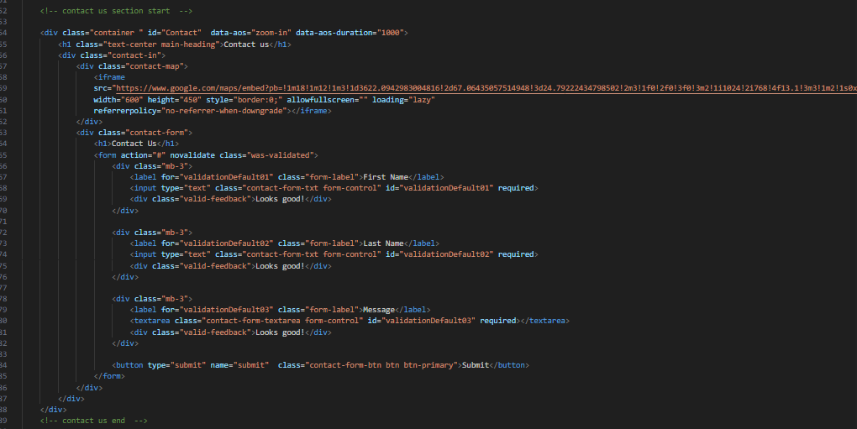CODE OF GRUOP EXCERCISE PAGE